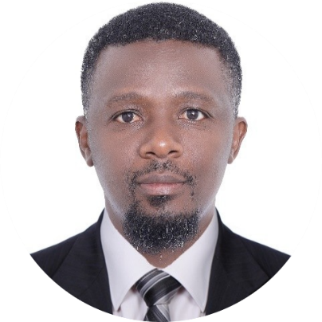

|  |  |
| --- | --- |
|  | **CLIFF NYAMONGO** Waiter |
| CONTACT +97152670565698 cliffnyamong@gmail.com  Dubai, UAE Education **Sensei Institute of Technology**  Certificate in Plant Operation  **Moi Institute of Science and Technology**  Diploma in Social work and Community Development  **Certificate in computer Applications**  **Nyamagwa Boys High School**  High School Diploma Skills  * Customer Service & Guest Relations * Cash Handling & POS Operations * Food & Beverage Service * Table Setting & Order Management * Upselling & Product Recommendations * Team Collaboration & Communication * Problem-Solving & Conflict Resolution | A customer-focused and service-oriented hospitality professional with extensive experience in restaurant operations. Skilled in delivering excellent customer service, handling transactions with accuracy, and ensuring smooth dining experiences. Adept at multitasking in fast-paced environments while maintaining a positive and welcoming atmosphere for guests Professional Experience**2019 – 2024 | Kilimanjaro Restaurant, Nairobi Kenya** **Waiter Cum Cashier**   * Welcomed and seated guests, provided menus, and guided them through food and beverage options to enhance their dining experience. * Managed order processing efficiently, ensuring accuracy and timely service in a high-volume restaurant. * Handled cash, credit, and mobile transactions at the point of sale, ensuring proper billing and financial reconciliation at the end of shifts. * Recommended menu items and promotions, increasing sales through upselling and personalized suggestions. * Maintained a clean, organized, and well-stocked dining area to ensure a pleasant environment for customers. * Resolved customer complaints and special requests with professionalism, ensuring guest satisfaction and repeat business.  **2015 – 2019 | Midview Hotel, Mombasa Kenya** **Waiter**   * Provided attentive table service, taking orders and delivering food and beverages efficiently in a high-end hospitality setting. * Assisted guests with menu selections, dietary preferences, and special meal requests, ensuring a tailored dining experience. * Collaborated with kitchen and bar staff to ensure seamless coordination of orders and prompt delivery. * Maintained high cleanliness and hygiene standards, adhering to hotel policies and health regulations. * Engaged with customers to create a warm and welcoming atmosphere, leading to positive reviews and increased guest loyalty.   **2011- 2015 | Multichoice Kenya Ltd, Kenya**  **Sales Associate**   * Assisted customers in selecting pay-TV packages and services that best suited their entertainment needs and budgets. * Processed new subscriptions, upgrades, and cancellations while ensuring accurate documentation and timely activation. * Conducted outbound calls to existing customers to promote new channels, packages, and special offers, driving upsell opportunities. * Resolved billing and service-related issues, ensuring customer satisfaction and retention. * Maintained up-to-date knowledge of the company’s products and services to provide accurate and informed recommendations. |